MRI AND ELECTROCARDIOGRAM IN EVALUATION OF HOMOGENEOUS INFARCT, PATCHY MICROINFARCT AND THE COMBINATION
L. Do, M.W .Wilson, J. Murayama, C. Stillson, S.W. Hetts, M. Saeed
University of California San Francisco, San Francisco, CA, USA

Objective: To evaluate the pathological and electrophysiological abnormalities caused by different ischemic insults.
Background: Myocardial infarct was classified based on pathological, clinical and prognostic differences. Coronary microembolization has been associated with valvular endocarditis, cardiomyopathy, mural thrombus, arrhythmias, hypertension, diabetes, systemic lupus erythematosus and sickle cell diseases.
Methods and Results: In swine (n=32), the tip of the catheter was placed in the LAD. The animals were subjected to different ischemic insults, namely 90min LAD occlusion/reperfusion, delivery of 80µm microemboli, the combination of the 2 insults and controls. Acute and evolving changes in electrophysiological were monitored using Holter monitor. Contrast enhanced MR imaging followed by histopathology was performed to define viable myocardium 3 days later and images were analayzed using semi-automatic threshold method. MR images showed different patterns of enhancements; namely hyperenhancement in large infarct, hypoenhancement in microvascular obstruction zone at the infarct core, moderately enhancement in patchy infarct at the infarct border, depending on the pathologies (Fig. 1). It provided the following estimations of the extent of myocardial damage in LAD occlusion/reperfusion group (12.4±0.8% LV mass), microembolized LAD (8.8±0.5%) and in the combined intervention (15.7±1.1%). These findings support the recently published MR data in 144 patients with a prior MI1. The electrophysiological abnormalities (ventricular and supraventricular ectopic activities) were not specific to the enhancement pattern or infarct size.
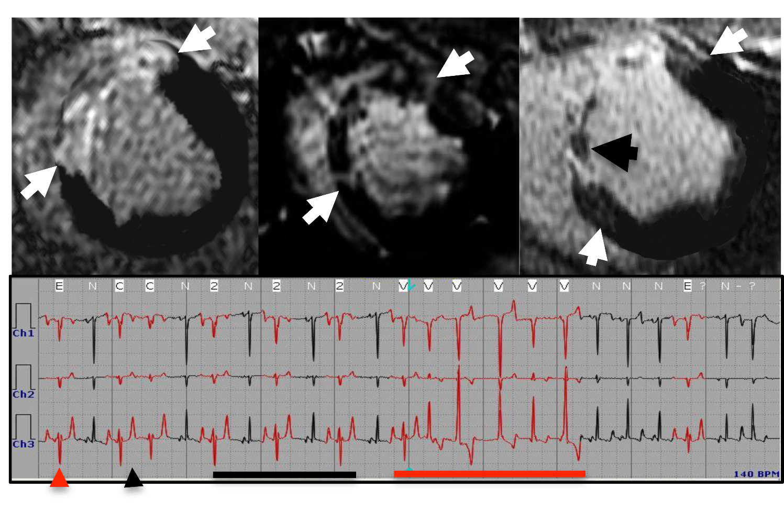
Conclusions: MRI differentiates acute myocardial infarct based on enhancement patterns and insult, while ECG provides limited diagnostic information on the type of insult. Reference: 1) Yan AT, et al. Circulation 2006;114:32-39.

Fig. 1. MRI (top) show enhanced myocardial damage (white arrows) and patterns in large infarct (left), patchy microinfarct (center) and the combination with hypoenhanced microvascular obstruction zone (black arrow) (right). ECG abnormalities caused by microemboli (bottom). Grey arrowheads=single and black= couplet PVC. Black lines =bigeminy and grey lines=LV run.

